

INFORMATICS INSTITUTE OF TECHNOLOGY

In Collaboration with

UNIVERSITY OF WESTMINSTER

**6MARK017W: Digital Marketing, Social Media & Web Analytics**

**Coursework 01**

**Ms. Noorul Amaanie Yoosuf**

**BSc (Hons) in Computer Science**

School of Computing & Engineering

College of Design, Creative & Digital Industries

University of Westminster

Word Count : XXXX

15.03.2024

# Table of Contents

Table of Contents i

List of Tables ii

List of Figures ii

Question 01 – Digital Marketing Models 1

Illustration and Discussion of Ash’s Funnel Process 1

Applicability of Ash’s Funnel Process on Mimosa 3

Definition of Technical Terms 4

Question 02 – Search Engine Optimization 5

Part A – Screenshots of Microsite 5

Part B - Form 7

Part C - Keyword Research 7

Part D - Website Optimization 12

Part E - Backlinks and Internal linking 13

Part F – PageRank Algorithm 17

Question 03 – Social Media & Traditional Marketing Methods 21

Part A - Social Signals 21

Part B – Social Media Marketing 23

References I

# List of Tables

Table 1: Technical Terms and Definitions 4

# List of Figures

Figure 1: Digital Marketing Funnel (Self-composed) 1

Figure 2: Acquisition Methods by Mimosa 3

Figure 3: Conversion Strategies by Mimosa 3

Figure 4: Retention Methods by Mimosa 4

Figure 5: Home Page 5

Figure 6: About Page 5

Figure 7: Restaurants Page 6

Figure 8: Gallery Page 6

Figure 9: Gastronomic Portal 6

Figure 10: Site Footer 7

Figure 11: Google Form 7

Figure 12: Keyword Density Analysis 8

Figure 13: Keyword Planner 01 9

Figure 14: Keyword Planner 02 10

Figure 15: Keyword Tree 11

Figure 16: Home Page before Optimization 12

Figure 17: Home Page after Optimization 12

Figure 18: About Page before Optimization 13

Figure 19: Home Page after Optimization 13

Figure 20: Backlink to Kumar Sangakkara's Site 14

Figure 21: Backlink to Mahela Jayawardene's Site 15

Figure 22: Outbound Links to YouTube & Newspaper Interviews 15

Figure 23: Outbound Link to Restaurants 16

Figure 24: Social Platform Links 16

Figure 25: Navigation Panel 17

Figure 26: Internal Links 17

Figure 27: PageRank Algorithm 18

# Question 01 – Digital Marketing Models

**Mimosa** (<https://mimosaforever.com/>) has been selected as the online company for this case study.

A digital marketing funnel is a framework that outlines the stages customers go through from awareness to purchase. Marketers use strategies tailored to each stage to guide customers smoothly through the process (Handley, 2023).

The funnel method introduced by Ash in 20212 has been widely used to guide customers from their product/service awareness stage and until a purchase in made. A detailed explanation of each stage of the Ash’s funnel process is presented below.

## Illustration of the Ash’s Funnel Process

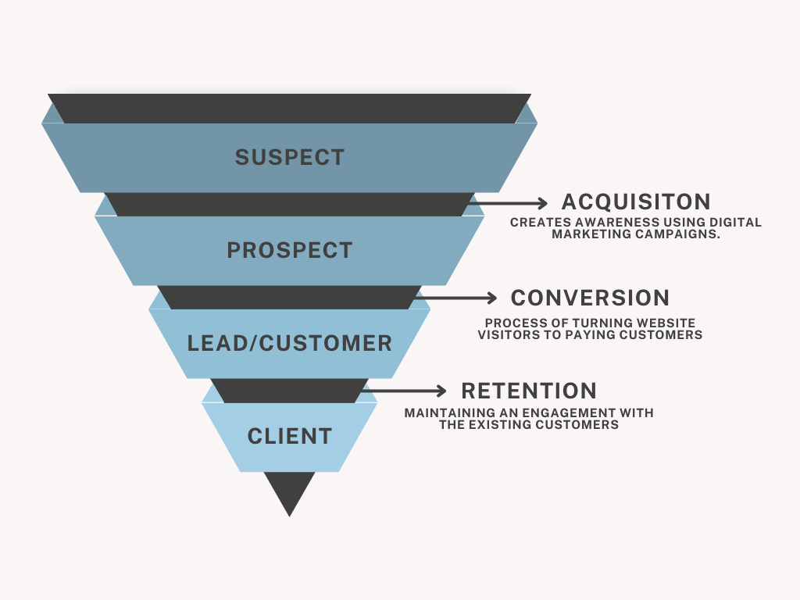

Figure 1: Digital Marketing Funnel (Self-composed)

## Significance of Each Stage in the Ash’s Funnel Process Discussed

**Suspects**

Individuals that have no prior affiliation with the organization, product or service provided. Further, they present no clear tendency towards potential future purchases (Kingsnorth, 2022).

**Acquisition**

During this stage, individuals (potential customers) are made aware of the establishment and learn about it via digital marketing campaigns such as, google searches, banner advertisements, email and social media marketing and other similar channels (FirstPageSage, 2024).

**Prospects**

These individuals are characterized by their initial expression of interest towards the product. Their interest could be demonstrated in multiple ways and aspects such as, visiting websites, subscriptions to services offered, and through inquiries (Kingsnorth, 2022).

**Conversion**

A prospect reaches this stage of the funnel when they have made a decision that the products and services offered by the organization align with their needs and requirements (FirstPageSage, 2024). It is during this stage that the prospect converts themselves into a customer once the initial purchase with the organization is established.

**Leads**

Entities that depict an in-depth interest towards purchasing the product or service offered by the organization. Leads exhibit their interest towards the organization’s services offered by filling out forms and signing up their newsletters. However, leads, shows potential in becoming a customer (Writer, 2020).

**Customers**

Upon completing the first purchases, entities transfer from leads to customers. From this moment of transactional engagement, a relationship will be established with the customer and the organization (Kingsnorth, 2022).

**Retention**

After the initial purchases has been made by the customer, it is essential to retain these existing customers due to multiple reasons, such as, acquiring new customers could be costly and customer retention is important to the organization since it depicts their trust bondage and treatment of existing customers. These customers can be retained by providing them with coupons, discount and email promotions (Writer, 2020).

**Clients**

Customers that have progressed beyond their initial purchase or transaction are entitled the term ‘Client’. Clients engage in repeated business with the establishment. Although there is no brand advocating conducted (Kingsnorth, 2022).

## Applicability of Ash’s Funnel Process on Mimosa

Mimosa *acquires potential customers* by introducing a subscription option upon their website visit. Additionally, they enhance user experience by deploying an appealing landing page featuring a user-friendly navigation panel, categorized according to their offerings. Furthermore, a chatbot system encourages customer engagement, inviting visitors to interact with the website.

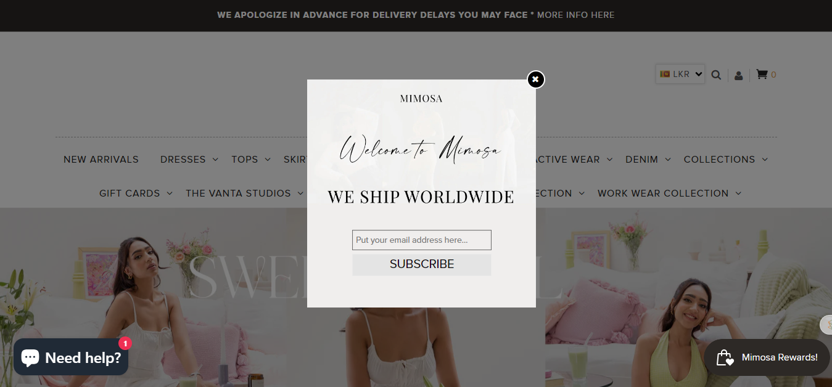

Figure 2: Acquisition Methods by Mimosa

Mimosa employs a seamless approach to *converting prospects into customers* through their active utilization of social media platforms and timeless and attractive collection. They maintain a robust social media campaign both in-store and on their website. Additionally, by offering clothing suitable for all seasons along with styling tips, Mimosa naturally attracts customers to engage with their brand.

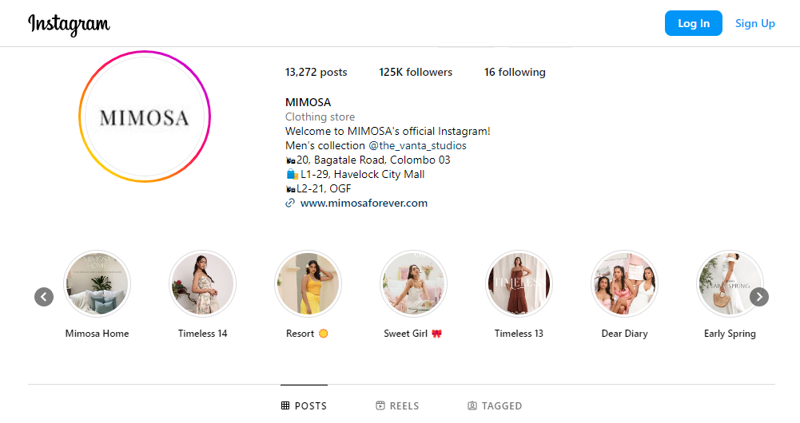

Figure 3: Conversion Strategies by Mimosa

To foster customer loyalty, Mimosa implements loyalty programs starting from the initial purchase. Customers can accrue points by joining their communities and following them on social media platforms, which can later be redeemed for future purchases. These initiatives not only encourage post-purchases interaction but also cultivate a sense of loyalty towards the brand.

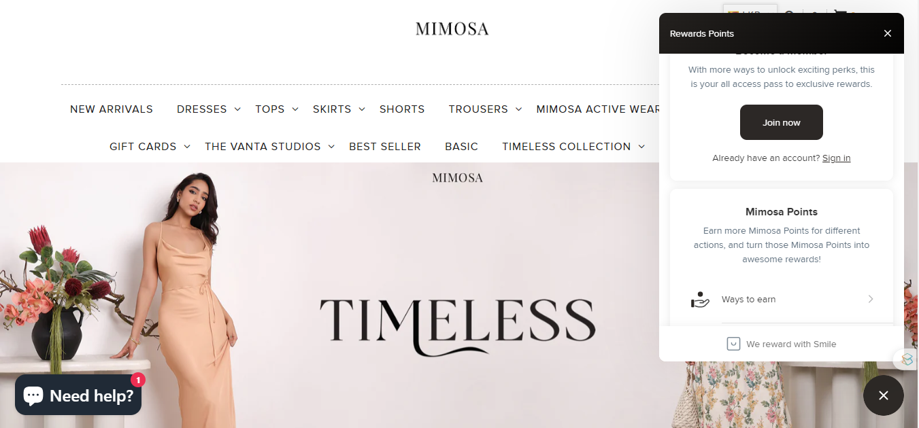

Figure 4: Retention Methods by Mimosa

In summary, Mimosa's adept utilization of the digital marketing funnel seamlessly guides customers from acquisition to retention, playing a pivotal role in the success of its digital marketing strategy.

## Definition of Technical Terms

|  |  |
| --- | --- |
| Technical Term | Definition |
| Transactional Engagement | Interactions where exchanges such as, purchases/negotiations take place between parties. |
| Social Media Campaign | Strategic activities on social media platform which assist in achieve business goals. |
| Banner Advertisements | Digital advertisements displayed on other websites to attract a wider user attention. |
| Post-purchase | Interactions with customers after a purchase is made. |
| Loyalty Programs | Strategies to reward customers for their repeated engagement with the organization, product or service. |

Table 1: Technical Terms and Definitions

# Question 02 – Search Engine Optimization

## Part A – Screenshots of Microsite

The created was created for, ***Dharshan Munidasa***,.

URL to the implemented site : <https://sites.google.com/iit.ac.lk/chefdharshanmunidasa>

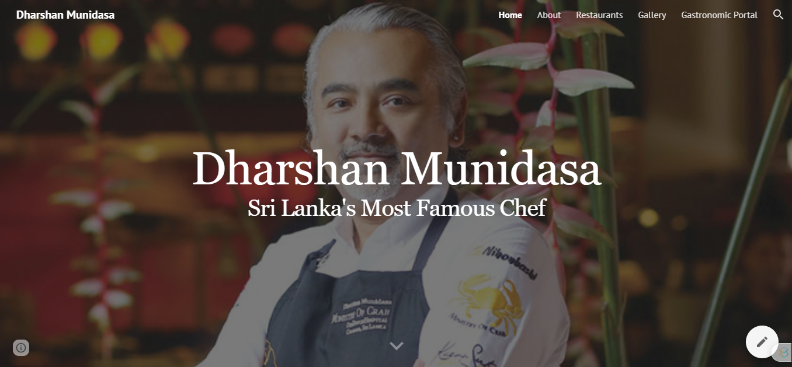

Figure 5: Home Page

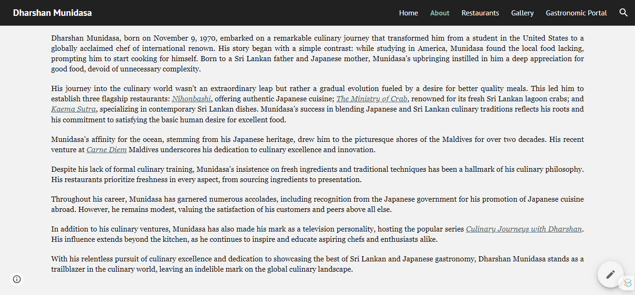

Figure 6: About Page

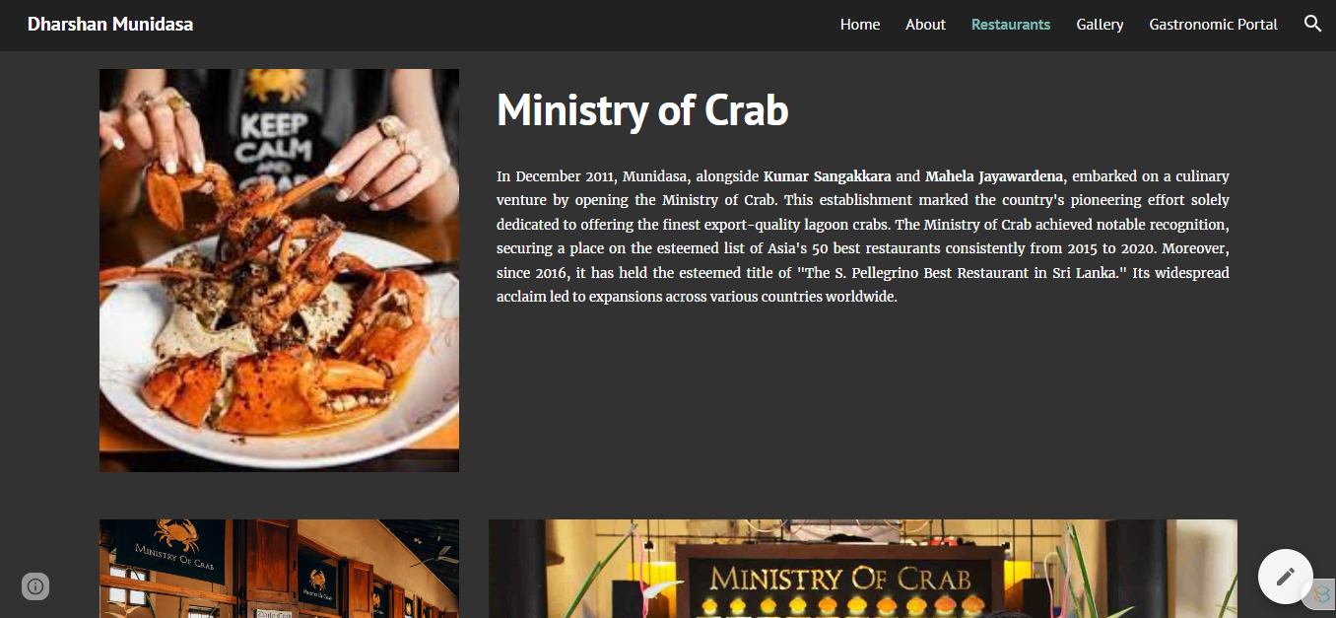

Figure 7: Restaurants Page

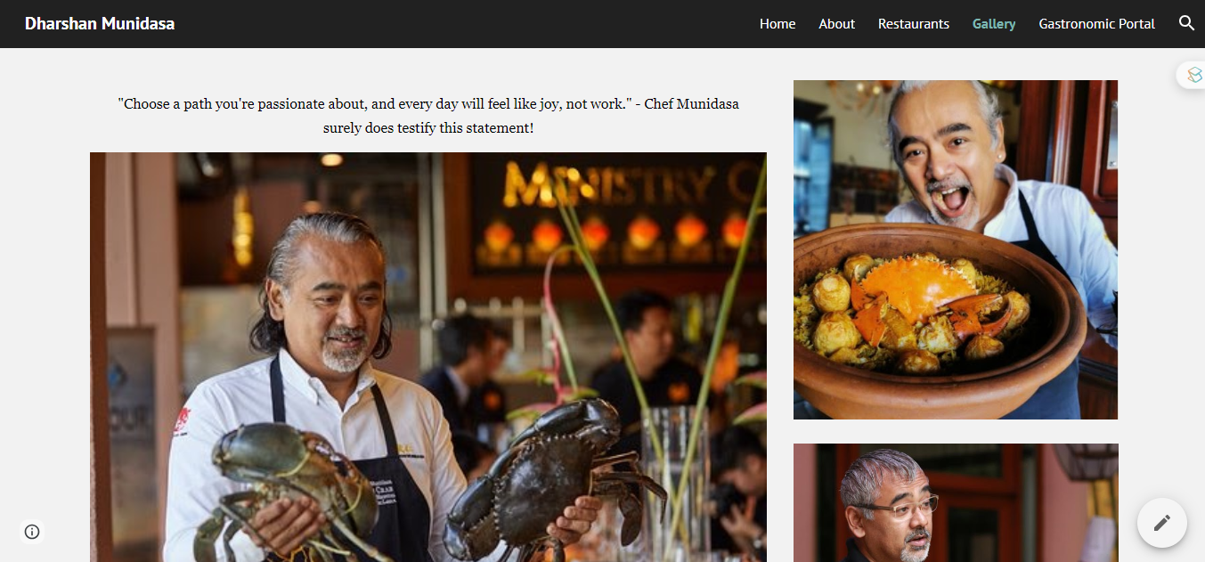

Figure 8: Gallery Page

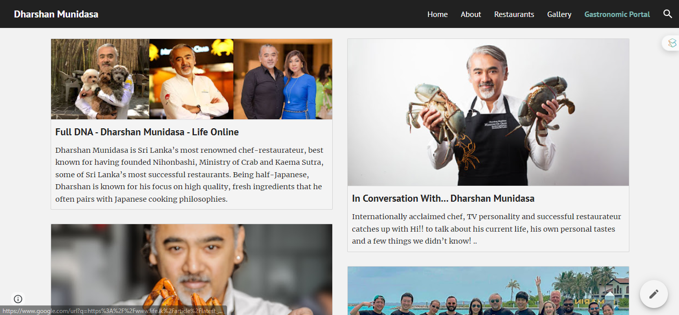

Figure 9: Gastronomic Portal

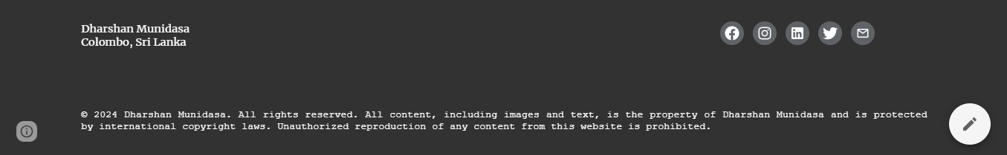

Figure 10: Site Footer

## Part B - Form

A google form was created to collect user data for the purpose of *email marketing*.

Form link - [Dharshan Munidasa's Newsletter](https://docs.google.com/forms/d/e/1FAIpQLScE3kQAOiwZD6v-Yrq7RUJVbnGbc0vnHLuZZAj9EYBqPz8Big/viewform)

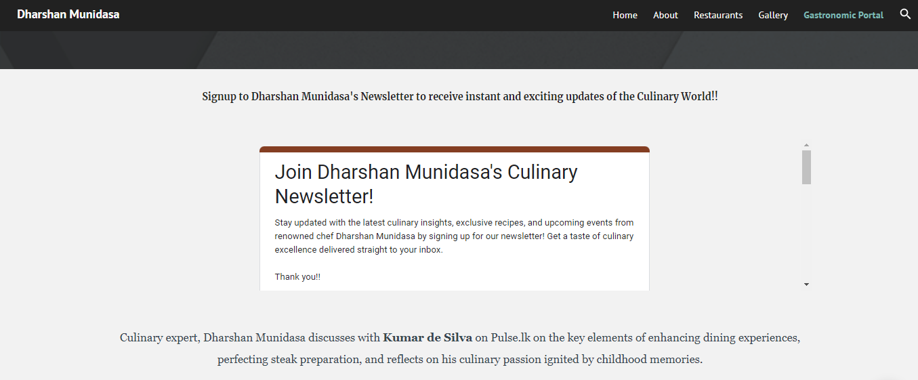

Figure 11: Google Form

## Part C - Keyword Research

Keyword Density is the measure of how often specific keywords or phrases appear on a webpage relative to the total word count of that page (Hamilton, 2023). The primary aim of this is to attain an ideal density that boosts the relevance of content to search engines without sacrificing its quality (Forsey, 2022).

The tool, [Internet Marketing Ninjas](https://www.internetmarketingninjas.com/tools/keyword-density/), was utilized to perform the keyword density analysis.

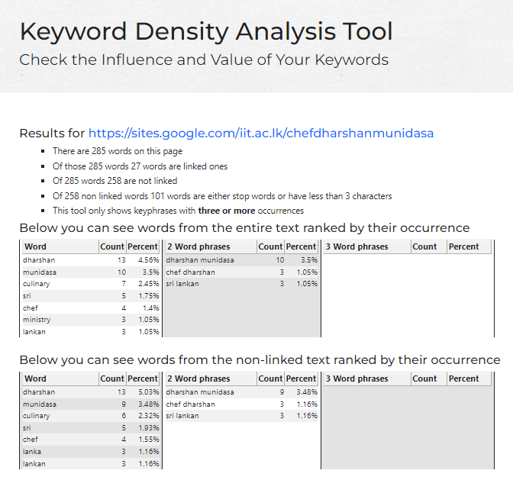

Figure 12: Keyword Density Analysis

Based on the KDA which was conducted, the below words and word phrases were considered “seed phrases” for the client,

* Dharshan
* Munidasa
* Dharshan Munidasa
* Chef Dharshan

**Search Volume** refers to the quantity of search queries conducted for a particular keyword term within a specified timeframe (Silva, 2023). Google's Keyword Planner serves as a tool for estimating search volume (Search volume - find the definition in the SEO Glossary, no date).

**Keyword Competitiveness** involves evaluating keywords that achieve high rankings based on their content. Additionally, factors such as domain authority, page authority, content quality, and click-through rates contribute to this level of competitiveness (Hey, 2023).

**Identification of Relevant Keywords**

The keywords identified through the KDA were inputted into the Google Keyword Planner to identify appropriate keywords and assess their competitiveness.

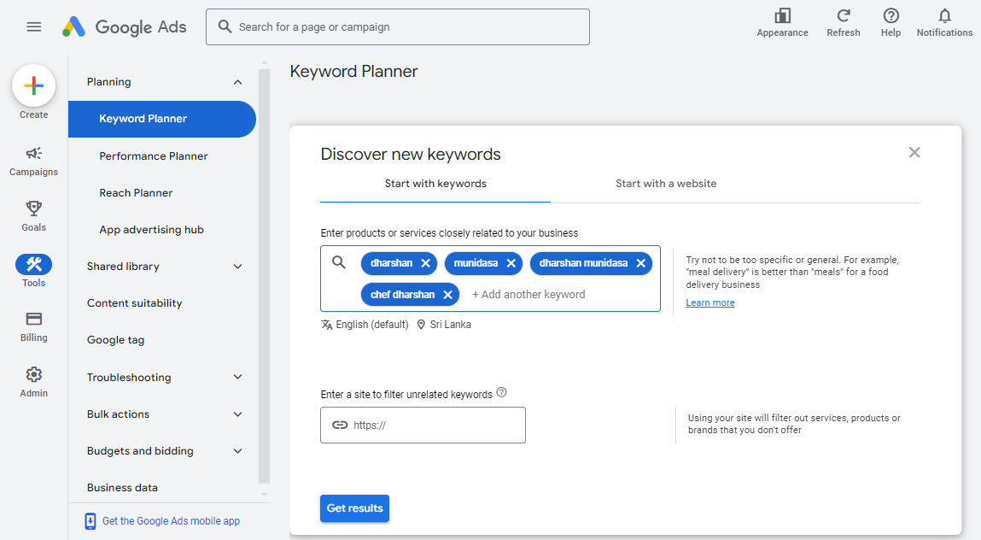

Figure 13: Keyword Planner 01

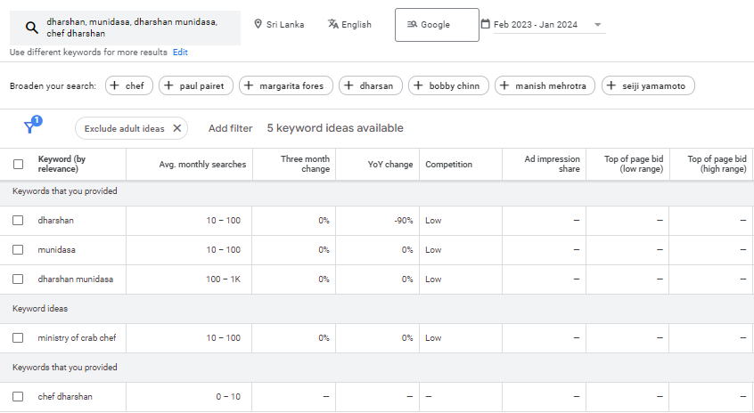

Figure 14: Keyword Planner 02

Based on the findings, the keywords "*Dharshan*" and "*Munidasa*" exhibit a monthly search volume ranging from 10 to 100, while "*Dharshan Munidasa*" holds an average search volume of 100 to 1000 per month. These keywords demonstrate low competition levels from February 2023 to January 2024.

According to the data provided by the Google Keyword Planner, "*Ministry of Crab Chef*" enjoys a high average monthly search volume of 10-100 and experiences low competition. Therefore, these keywords are suitable for optimizing the site's content.

**Keyword Tree**

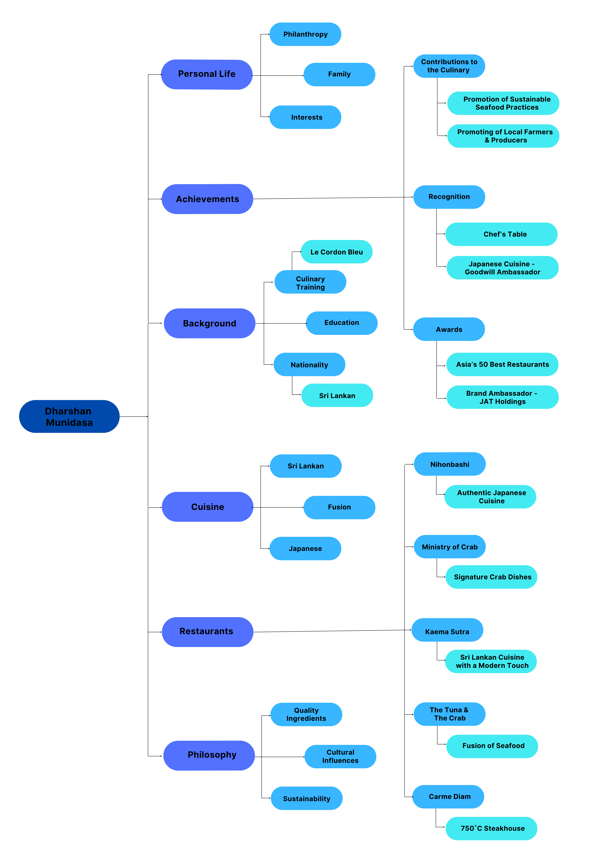

Figure 15: Keyword Tree

## Part D - Website Optimization

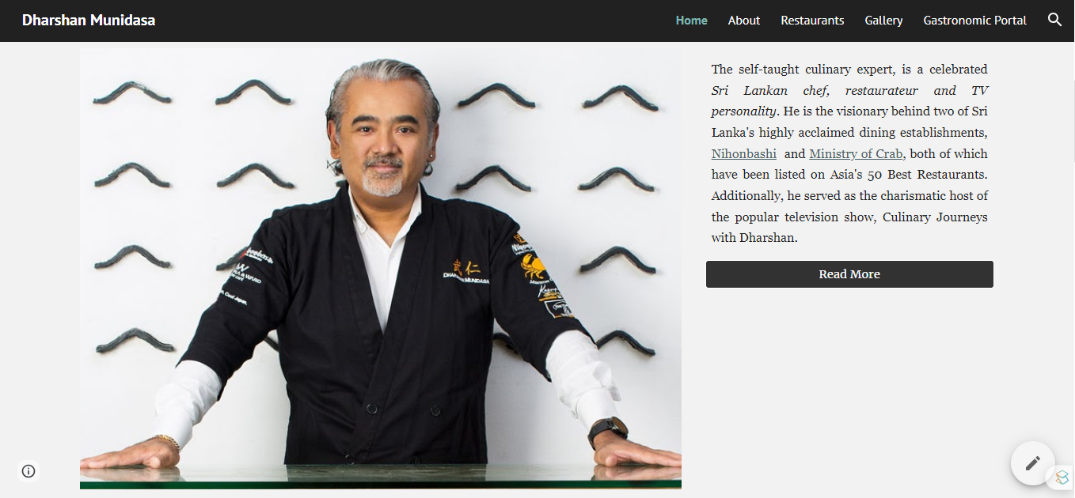

Figure 16: Home Page before Optimization

The content underwent optimization by incorporating the identified keywords obtained from the Google Keyword Planner, aligning with the seed phrases identified during the KDA. Integration of these keywords was done to maintain a natural flow within the content. The celebrity's full name was introduced in the introduction and other relevant sections; however, to avoid redundancy, alternatives like "Munidasa" were utilized.

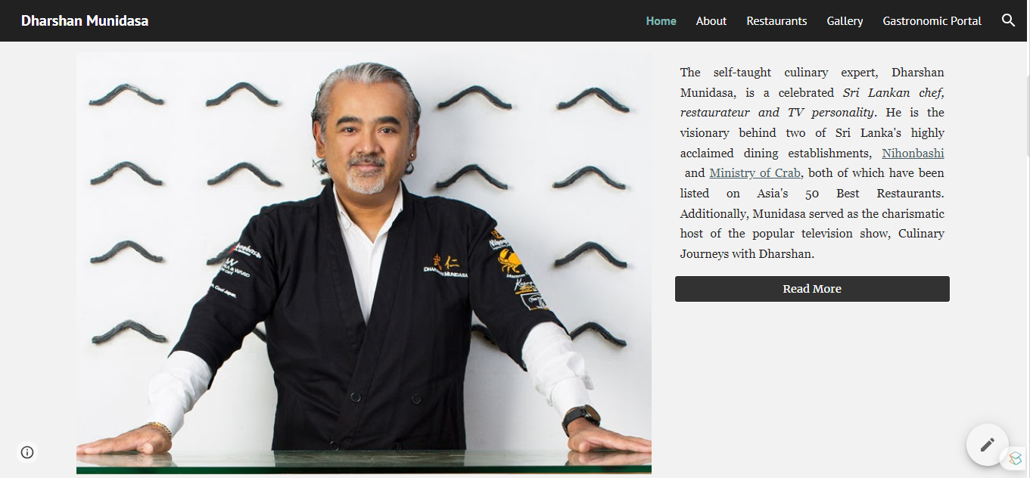

Figure 17: Home Page after Optimization

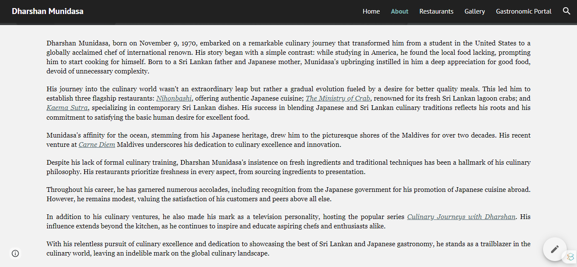

Figure 18: About Page before Optimization

The content featured on the "About" page naturally revolves around keywords such as "Dharshan," "Munidasa," and "Dharshan Munidasa," centering on the narrative of Dharshan Munidasa's culinary journey. While these keywords were utilized, they were applied judiciously without excessive repetition, ensuring their appropriateness within the context. Additionally, the suggested keyword from the Google Keyword Planner, "Ministry of Crab chef," has been appropriately incorporated into the content.

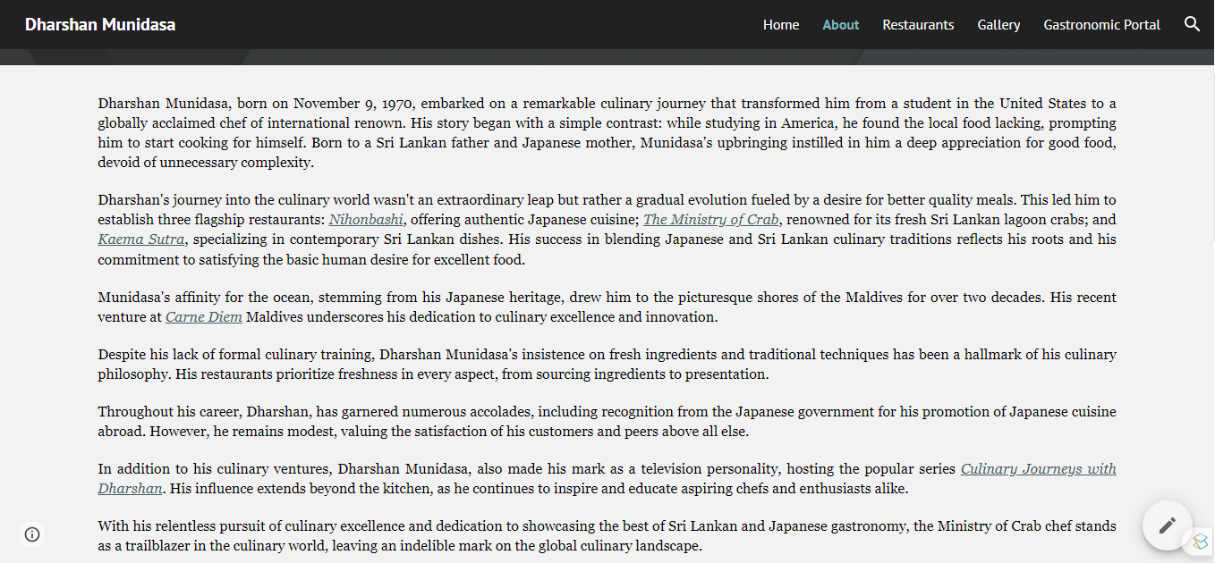

Figure 19: Home Page after Optimization

## Part E - Backlinks and Internal linking

**Backlinks** are links originating from external websites that direct traffic to a specific page on your site(Ahern, 2023). These links play a crucial role in enhancing SEO performance, as both their quality and quantity influence a website's search engine ranking, indicating trustworthiness (Lyons, 2023).

Furthermore, backlinks are often considered as "votes" from other websites, each contributing to the credibility and value of the linked website's content (Dean, 2019). Therefore, one of the most effective strategies for achieving higher rankings on search engines like Google is to incorporate high-quality backlinks, as they attract a broader audience and bolster a site's authority (Ahern, 2023).

Dharshan Munidasa maintains strong connections with multiple well-known figures in Sri Lanka. As a result, this site has been linked with theirs, fostering collaboration and cross-promotion between their respective platforms.

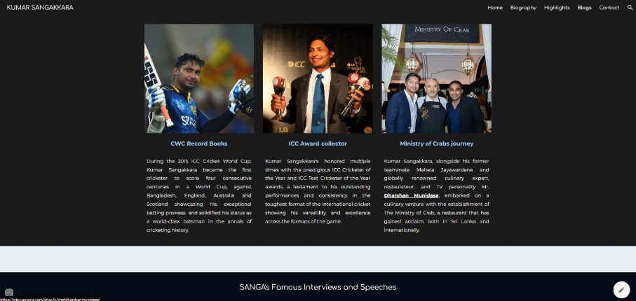

Figure 20: Backlink to Kumar Sangakkara's Site

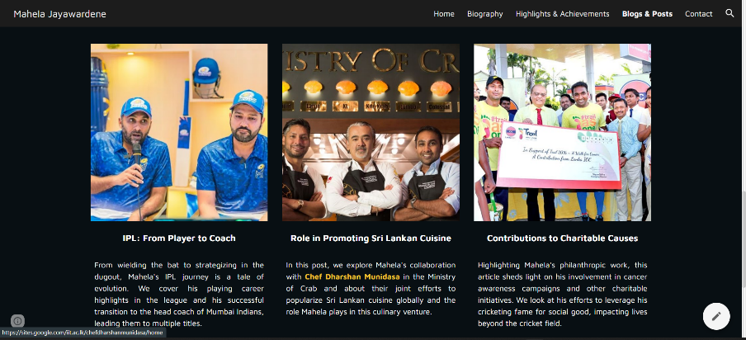

Figure 21: Backlink to Mahela Jayawardene's Site

Outbound links to YouTube videos and newspaper interviews, social media profiles, and restaurants owned by Munidasa have been incorporated into the site.

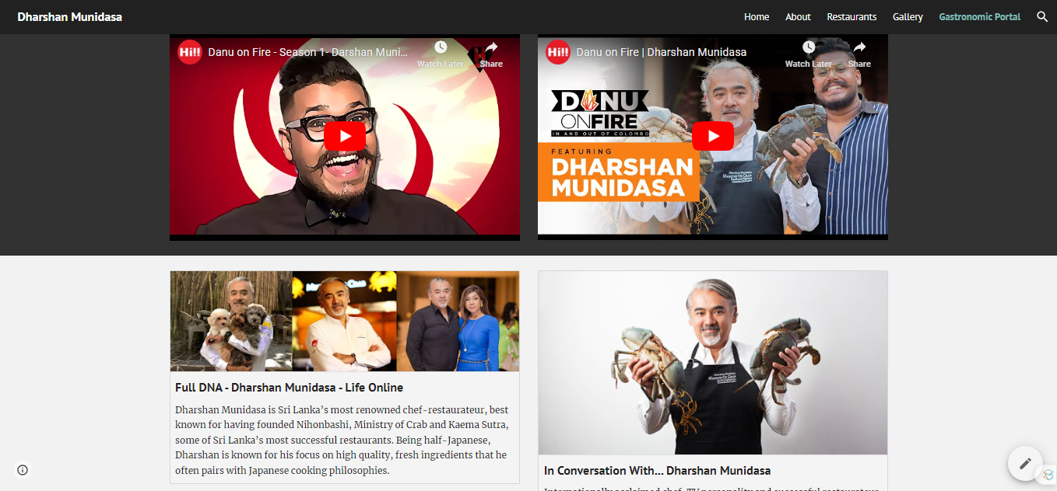

Figure 22: Outbound Links to YouTube & Newspaper Interviews

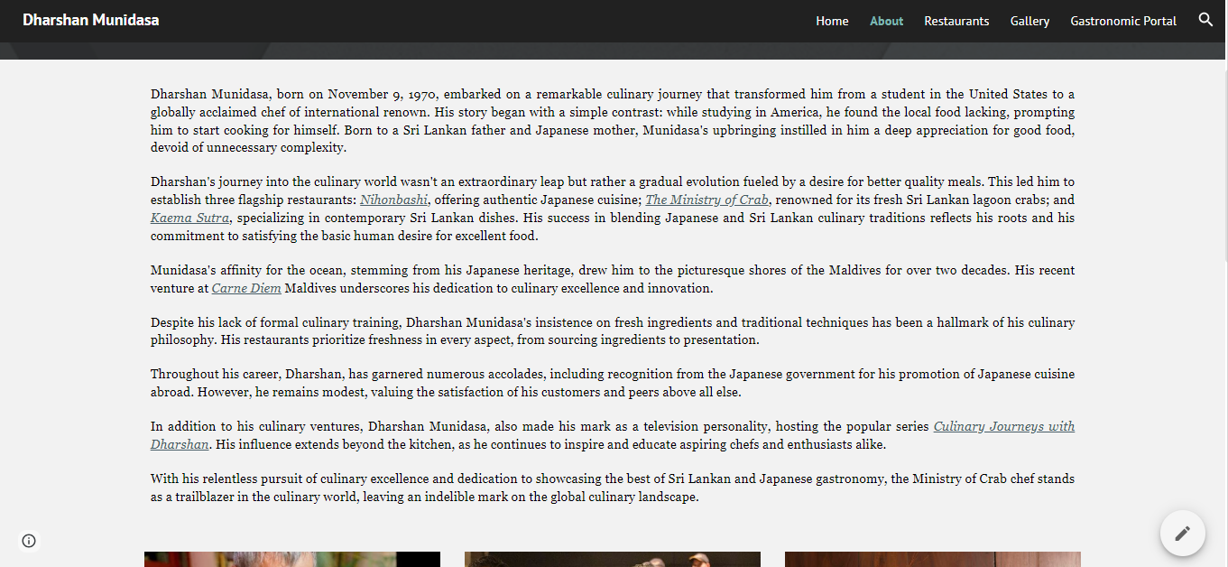

Figure 23: Outbound Link to Restaurants

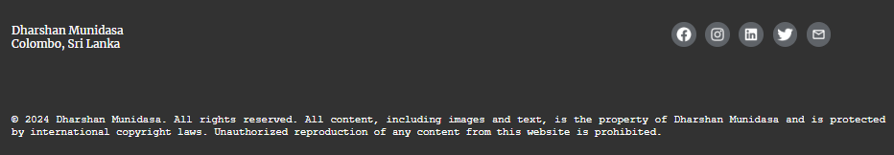

Figure 24: Social Platform Links

**Internal Linking**

Internal links are hyperlinks that connect various pages within the same website domain, facilitating navigation and access to relevant content. They play a pivotal role in providing structure and navigation within a website (Harsel, 2023).

These links can be located in the main navigation menu, footer, or embedded within textual content on webpages (Bhan, 2023). Moreover, internal links assist search engines like Google in discovering, indexing, and comprehending all pages within a website. When employed strategically, these links contribute to higher search engine rankings, as Google perceives pages with valuable internal links as more significant, thereby enhancing the website's visibility (Dean, 2023).

Internal links have been integrated into the microsite's navigation panel, enhancing user experience by facilitating seamless navigation between webpages.

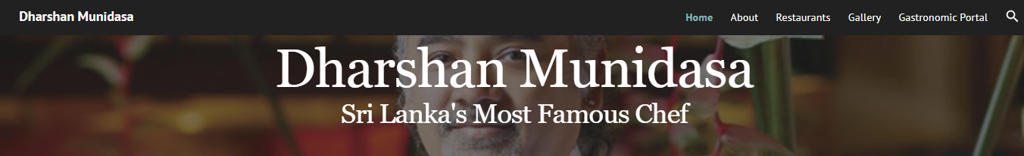

Figure 25: Navigation Panel

Additionally, buttons have been strategically placed throughout the website, redirecting users to relevant pages within the site, further improving usability and ensuring a smooth browsing experience.

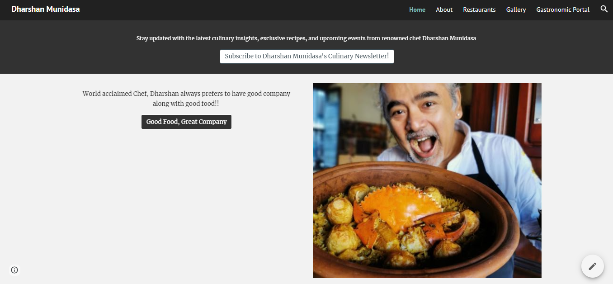

Figure 26: Internal Links

## Part F – PageRank Algorithm

PageRank is a webpage ranking system pioneered by Larry Page and utilized by Google to gauge the significance of webpages, primarily based on the quality and quantity of inbound links they receive(Varangouli, 2023). Each inbound link functions as a recommendation or endorsement for the webpage, incrementally boosting its rank (Yell, 2011).

The PageRank is computed through a proprietary mathematical formula that treats each link to a webpage as a vote of confidence. This process resembles a popularity contest, where the webpage is compared to others with similar content and keywords. Ultimately, the webpage with the highest number of valuable links earns a higher rank (Leuangpaseuth, 2022).

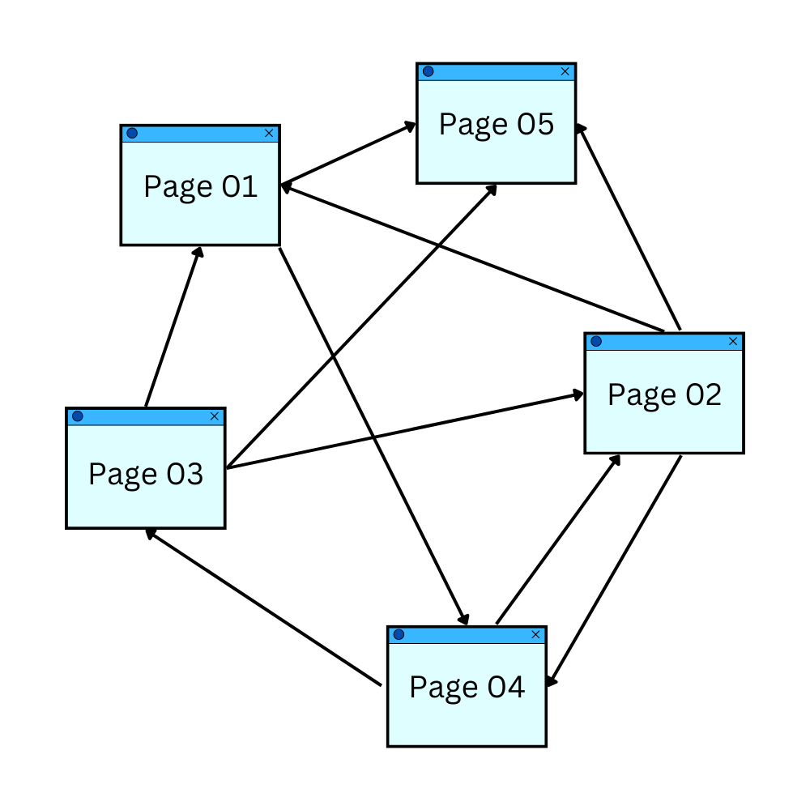

Figure 27: PageRank Algorithm

**Rationale and Intuition behind the Page Rank Algorithm**

**Links as Votes**

Originally, PageRank operated on the principle that links served as endorsements, reflecting trust and authority towards a website. In this view, an increased number of links equated to a greater number of endorsements, leading to higher precedence for websites with a greater quantity of links and thus a higher rank (Varangouli, 2023).

**Quality of Votes**

While links indeed function as votes for websites, their significance isn't uniform across the board. The weight of a vote is contingent upon the importance of the source site and its content. Consequently, the more popular and significant the source site, the more substantial the value of the vote it provides (Hall, no date).

**Iterative Process**

Within the PageRank algorithm, the iterative process continues until convergence is reached, signaling stability in rank. The resultant PageRank scores reflect the importance of individual webpages, with higher-ranked pages being perceived as more influential and thus more likely to be prominently displayed in search engine results (PageRank Algorithm - javatpoint, no date).

**Manipulation and Countermeasures in Page Ranking**

**Manipulation**

Initially, the PageRank score was openly displayed in the Google Toolbar. Over time, as web pages became inundated with keywords and website owners sought to manipulate PageRank, they resorted to artificially injecting spam links and backlinks into their sites. (Verzhbitskaia, 2024).

* *Link Farming* are online platforms established with the sole intention of manipulating search engine rankings by artificially inflating the number of links pointing to a particular website. While these sites may appear similar to legitimate websites, their content predominantly consists of fabricated hyperlinks and irrelevant material. This practice represents a black hat SEO tactic, involving the unethical creation of backlinks. (Shelepin, 2023).
* *Keyword Stuffing* occurs when a website is excessively filled with keywords in an unnatural manner, with the aim of enhancing its ranking in search engine results (Handley, 2023). This practice leads to the creation of low-quality content and has adverse effects on SEO rankings and visibility (Sheppard, 2022).
* *Cloaking* is a deceptive SEO technique where a website presents one set of content to search engines exclusively for the purpose of improving its ranking, while displaying entirely different content to its actual visitors (Hilson, 2022). This misleading practice aims to manipulate the search engine algorithm in order to attain a higher rank (Johansen, 2023).
* *Paid Linking* are hyperlinks acquired through monetary transactions with the intention of artificially elevating a website's search engine rankings. This method, aimed at improving rankings, contravenes Google's guidelines as it represents a shortcut to achieving a high PageRank (Gosset, 2023).

**Countermeasures**

To address the manipulative tactics associated with PageRank, Google implemented a series of countermeasures and algorithm updates aimed at preventing forced ranking and manipulation of SEO (Leuangpaseuth, 2022; Varangouli, 2023).

* *Panda Update* - Introduced in 2011, this significant algorithm update aimed to decrease the ranking of "low-quality sites" while rewarding higher rankings to websites of better quality. (Goodwin, 2024).
* *Penguin Update* - Launched in 2012, the Webspam Algorithm, later known as the Penguin Update, targeted manipulative and inappropriate link-building practices such as link buying, keyword stuffing, and cloaking (Jain, 2022).
* *Hummingbird Update* - Launched in 2015, this update focused on enhancing Google's semantic search capabilities. The algorithm aimed to deliver more relevant results for complex conversational search queries. Consequently, it filtered out irrelevant content generated solely for SEO purposes (Yu, 2013).

# Question 03 – Social Media & Traditional Marketing Methods

## Part A - Social Signals

Social signals encompass various forms of engagement or interaction with a social media platform or its content (Bhan, 2022). These interactions include likes, comments, shares, and more.

The concept of social signals emerged and progressed alongside the rise of social media platforms with a vast audience increasingly dedicating time to engaging and interacting with content, social signals have become integral to online communication and marketing strategies. (Schaffer, 2024).

Below are several examples of social platforms and associated social signals:

* Facebook – follows, likes, comments, views, shares
* Instagram – follows, likes, comments, shares, saves, reposts
* Twitter – follows, tweets, retweets, replies
* LinkedIn – connections, likes, comments, shares

**Social Signals in Search Engine Algorithms**

While social signals may not directly influence Google rankings, they play a crucial role in enhancing brand visibility in search results, driving traffic to websites, and fostering brand awareness (Team, 2023). Appropriately optimizing social signals and incorporating effective calls-to-action (CTAs) can significantly improve visibility and attract attention to a website (Schaffer, 2024). Additionally, producing high-quality content can positively impact the performance of the site (Bhan, 2022).

**Advantages of Social Signals**

Improved Search Engine Rankings

Social signals exert a favorable impact on search engine rankings as they signify content relevance, popularity, and authority. Consequently, websites that garner substantial social interaction are inclined to attain higher rankings (Sanghera, 2023).

Enhanced Brand Visibility

Producing compelling and informative content encourages users to engage with the brand on social media, naturally expanding its reach to a broader audience and ultimately enhancing brand recognition (Shah, 2023).

Credibility and Trust

Elevated levels of social engagement convey trustworthiness and credibility to users. Authentic user reviews and interactions inspire confidence in the brand and draw a larger audience (Sanghera, 2023).

Audience Engagement and Interaction

Audiences are inclined to engage with content that has garnered social validation through likes, shares, and positive comments (Team, 2023) .

User-generated Content

Social signals empower users to generate and distribute their content based on their experiences, resulting in valuable content that amplifies brand visibility and credibility (Jarvis, no date).

**Limitations of Social Signals**

Inaccurate Content Representation

Social signals may not consistently offer reliable indicators of content quality or relevance. Additionally, substantial social engagement does not necessarily guarantee the presence of high-quality content (Kavitha, 2023).

Vulnerability to Manipulation

Social signals are susceptible to manipulation through methods like purchasing followers, likes, and shares. Such tactics can distort social metrics without reflecting authentic user engagement or interests (Kavitha, 2023).

Privacy Concerns

The collection of social signals has the potential to raise privacy concerns among users of social media platforms, especially if their data is utilized without their consent or awareness (Shah, 2023).

**Recent Trends in the Search Engine Market and Consumer Reach Behavior**

The search engine market is continuously evolving and is projected to experience substantial growth between 2023 and 2030 (Industry Research & Forecast Reports, 2023). Search Engine Marketing (SEM) stands as a potent digital marketing strategy, involving the promotion of websites to enhance visibility in search engine results pages. In today's digital landscape, SEM has become indispensable for online businesses (Shah, 2024). However, to fully capitalize on its benefits, it is essential to remain abreast of the latest trends and practices.

In recent years, **Artificial Intelligence (AI) and Machine Learning (ML)** have been swiftly integrated into SEM, enabling automation of tasks, more efficient data analysis, and personalized content delivery (Wilkinson, 2023). Moreover, the surge in voice assistants has propelled **Voice Search** to the forefront, revolutionizing how individuals seek information and engage with brands (Shah, 2024). Therefore, marketers must optimize their content to align with this trend to stay competitive. Additionally, the prevalence of **Mobile-First Indexing** underscores the importance of optimizing websites for mobile devices, given the majority of users' reliance on mobile devices for search purposes(Shah, 2024).

Consumers commonly utilize search engines to research products or services before making purchase decisions. Hence, brands must effectively leverage **SEO techniques** to attract consumers throughout their decision-making process (Kaur, Singh and Kaur, 2020). Furthermore, **social media platforms** significantly influence consumer search behavior, as brands maintain a strong presence on these platforms and engagement with consumers proves advantageous (Ahmed, 2016). **Pay-per-click advertising** can also shape consumer search behavior by reaching a broader audience through targeted advertisements (Kaur, Singh and Kaur, 2020). Finally, **email marketing** remains an effective technique for delivering personalized and targeted information to consumers (Kumar and Chhabra, 2022).

## Part B – Social Media Marketing

**Consumer & Producer**

**Consumers** are individuals that purchase goods and services to satisfy their needs and wants. They are the end-users of products and services.

**Producers** are also identified as firms and business. These entities produce goods and services for consumption by consumers. Producers are responsible for manufacturing or providing the goods and services.

**Long-term Consumer-Producer Relationship**

A long-term consumer-producer relationship refers to a durable and continuous interaction between these two entities spanning an extended duration which leads to higher consumer lifetime value (Aberle, 2023). This bond is forged as consumers consistently procure goods or services from the producer, fostering loyalty and trust (Singh, 2021). Key attributes of such relationships include transparent communication, facilitating feedback and suggestions (Singh, 2021). Additionally, producers, acknowledging the trust and loyalty of consumers, provide value-added services like exclusive discounts, reward programs, and personalized offerings (Sorce and Edwards, 2004)

**Strengthening Consumer-Producer Relationship using Social Media Marketing**

Social media marketing plays a pivotal role in enhancing consumer-producer relationships through various avenues. One of its distinct advantages lies in its authenticity, as interactions are public, allowing followers to observe how all customers are treated. Therefore, even a single interaction can leave a lasting impression on consumers (Smith, 2023). Producers can leverage the following strategies to strengthen their relationships with consumers:

* Engagement and Interaction

Social media platforms provide producers with opportunities to engage with consumers through compelling content and social signals. This ongoing interaction fosters a sense of rapport and loyalty over time (Smith, 2023).

* Transparency and Authenticity

Transparency and authenticity are paramount in building trust with consumers. Sharing behind-the-scenes content and user-generated content such as reviews and feedback creates an open and welcoming environment (Jibril et al., 2019).

* Personalization

Social media platforms enable producers to customize content and offers to align with consumer needs and preferences. This personalized approach cultivates a sense of belonging and appreciation among consumers, attracting them to the business (Smith, 2023).

* Promotion and Awareness

Social media serves as a powerful marketing tool for promoting products, sharing updates, and announcing special offers and events. These efforts increase brand visibility and awareness among consumers, driving engagement and loyalty (West, 2023).

**Real-world Example**

Dove: #RealBeauty Campaign

The Dove Real Beauty campaign stands out as a prime example of how social media can fortify consumer-producer relationships.

The initiative aimed to defy traditional beauty norms and promote body positivity and self-acceptance. Featuring real women of diverse body types, the campaign challenged the typical standards seen in beauty advertisements (Thomas, 2023).

Dove actively encouraged women to share their personal stories and experiences on social media using the hashtag #RealBeauty. This user-generated content not only amplified the campaign's message but also nurtured a sense of community and solidarity among women. (Bajpai, 2023).

# References

Aberle, L. (2023). What is Relationship Marketing? - Definition from WhatIs.com. *Customer Experience*. Available from https://www.techtarget.com/searchcustomerexperience/definition/relationship-marketing [Accessed 12 March 2024].

Ahern, P. (2023). What Is a Backlink [And Why Do They Matter]? *Intergrowth®*. Available from https://intergrowth.com/seo/backlinks/ [Accessed 10 March 2024].

Ahmed, N. (2016). Online consumer behaviour. *International Journal of Commerce and Business Management*, 9 (1), 96–101. Available from https://doi.org/10.15740/HAS/IJCBM/9.1/96-101 [Accessed 12 March 2024].

Bajpai, A. (2023). (1) Dove’s ‘Real Beauty’ Campaign: A Marketing Case Study | LinkedIn. Available from https://www.linkedin.com/pulse/doves-real-beauty-campaign-marketing-case-study-abhishek-bajpai-8iwyc/ [Accessed 12 March 2024].

Barenholtz, L. (2023). How To Do Competitive Keyword Research. *Similarweb*. Available from https://www.similarweb.com/blog/marketing/seo/competitive-keyword-research/ [Accessed 9 March 2024].

Bhan, M. (2022). 10 Ways to Improve Your Social Signals for SEO. *WordStream*. Available from https://www.wordstream.com/blog/ws/2022/10/20/social-signals-for-seo [Accessed 10 March 2024].

Bhan, M. (2023). Internal Linking: Types, Tips & Tactics to Improve Your SEO. *WordStream*. Available from https://www.wordstream.com/blog/ws/2022/05/04/internal-linking [Accessed 10 March 2024].

Dean, B. (2019). What Are Backlinks in SEO? & Why You Need Them. *Backlinko*. Available from https://backlinko.com/hub/seo/backlinks [Accessed 10 March 2024].

Dean, B. (2023). Internal Linking for SEO: The Complete Guide. *Backlinko*. Available from https://backlinko.com/hub/seo/internal-links [Accessed 10 March 2024].

FirstPageSage. (2024). The Digital Marketing Funnel Stages, Explained – First Page Sage. Available from https://firstpagesage.com/seo-blog/digital-marketing-funnel-stages-fc/ [Accessed 17 February 2024].

Forsey, C. (2022). The Beginner’s Guide to Keyword Density. Available from https://blog.hubspot.com/marketing/keyword-density.

Goodwin, D. (2024). Lookback: Google Panda algorithm update launched 13 years ago. *Search Engine Land*. Available from https://searchengineland.com/google-panda-update-guide-381104 [Accessed 10 March 2024].

Gosset. (2023). What are Paid Links in SEO and Do They Work? Available from https://aioseo.com/what-are-paid-links-in-seo/ [Accessed 10 March 2024].

Hall. (no date). The Google Ranking Algorithm: Why is it So Important? | Five Channels. *Inbound Marketing Services and One Account Manager*. Available from https://fivechannels.com/the-google-ranking-algorithm-why-is-it-so-important/ [Accessed 10 March 2024].

Hamilton, D. (2023). Complete Guide to Keyword Density: What’s The Impact on SEO? *Zero Gravity Marketing*. Available from https://zerogravitymarketing.com/complete-guide-to-keyword-density-in-seo/ [Accessed 7 March 2024].

Handley, R. (2023). Keyword Stuffing in SEO: What It Is & How to Avoid It. *Semrush Blog*. Available from https://www.semrush.com/blog/keyword-stuffing/ [Accessed 10 March 2024].

Handley, R. (2023). The Marketing Funnel: What It Is & How It Works. *Semrush Blog*. Available from https://www.semrush.com/blog/marketing-funnel/ [Accessed 17 February 2024].

Harsel, L. (2023). Internal Links: Ultimate Guide + Strategies. *Semrush Blog*. Available from https://www.semrush.com/blog/internal-links/ [Accessed 10 March 2024].

Hey, R. (2023). What is keyword competitiveness and what does it mean for your web content? Available from https://strategically.co/blog/seo/keyword-competitiveness/ [Accessed 9 March 2024].

Hilson. (2022). Cloaking in SEO: Everything You Need to Know About It. *Rock Content*. Available from https://rockcontent.com/blog/cloaking-in-seo/ [Accessed 10 March 2024].

Industry Research & Forecast Reports. (2023). (2) Search Engine Market - Growth, Trends and Forecast (2023 - 2030) | LinkedIn. Available from https://www.linkedin.com/pulse/search-engine-market-growth-trends/ [Accessed 12 March 2024].

Jain. (2022). A Complete Guide To the Google Penguin Algorithm Update - echoVME Digital. Available from https://echovme.in/blog/complete-guide-to-google-penguin-algorithm-update/ [Accessed 10 March 2024].

Jarvis, Z. (no date). Does Social Media Marketing Really Benefit Your Search Ranking? | Exprance. *https://www.exprance.com/*. Available from https://www.exprance.com/social-media-marketing-benefit-search/ [Accessed 11 March 2024].

Jibril, A.B. et al. (2019). The impact of social media on consumer-brand loyalty: A mediating role of online based-brand community. *Cogent Business & Management*, 6 (1), 1673640. Available from https://doi.org/10.1080/23311975.2019.1673640 [Accessed 12 March 2024].

Johansen. (2023). What Is Cloaking in SEO? Your Ultimate Guide. *SEO.com*. Available from https://www.seo.com/basics/glossary/cloaking/ [Accessed 10 March 2024].

Kaur, D., Singh, G. and Kaur, G. (2020). Impact of Digital Marketing on Consumer Behaviour For E-Commerce. *Journal of emerging technologies and innovative research*, 7 (11), 981–984. Available from https://typeset.io/papers/impact-of-digital-marketing-on-consumer-behaviour-for-e-2oajecuv2t [Accessed 12 March 2024].

Kavitha, M. (2023). A study on disadvantage and impact on Digital Marketing. Available from https://doi.org/10.6084/m9.figshare.24763257.

Kingsnorth, S. (2022). *Digital marketing strategy: an integrated approach to online marketing*, Third Edition. London ; New York, NY: Kogan Page Limited.

Kumar, S. and Chhabra, A. (2022). A study of digital marketing and its impact on consumer behaviour in the indian context. *Towards excellence*, 1695–1717. Available from https://doi.org/10.37867/te1402140 [Accessed 12 March 2024].

Leuangpaseuth, B. (2022). What Is Pagerank? And Does It Matter For SEO Anymore? | Clearscope. Available from https://www.clearscope.io/blog/what-is-pagerank [Accessed 10 March 2024].

Lyons, K. (2023). What Are Backlinks & Why They Matter in SEO. *Semrush Blog*. Available from https://www.semrush.com/blog/what-are-backlinks/ [Accessed 10 March 2024].

PageRank Algorithm - javatpoint. (no date). *www.javatpoint.com*. Available from https://www.javatpoint.com/pagerank-algorithm [Accessed 10 March 2024].

Sanghera, R. (2023). What are Social Signals in SEO & How Does Social Media Impact SEO? Available from https://www.creativeideaz.co.uk/blog/what-are-social-signals-in-seo-how-does-social-media-impact-seo [Accessed 11 March 2024].

Schaffer, C. (2024). Social Signals and SEO: What You Need to Know (and 7 Steps to Take). *Social Media & Influencer Marketing Speaker, Consultant & Author*. Available from https://nealschaffer.com/social-signals-seo/ [Accessed 10 March 2024].

Search volume - find the definition in the SEO Glossary. (no date). *Conductor*. Available from https://www.conductor.com/academy/glossary/search-volume/ [Accessed 9 March 2024].

Shah, D. (2024). Staying Ahead of the Latest Search Engine Marketing Trends. *2Stallions*. Available from https://2stallions.com/blog/staying-ahead-of-the-latest-search-engine-marketing-trends/ [Accessed 12 March 2024].

Shah, R. (2023). Advantages & Disadvantages of Social Media Marketing. Available from https://www.sprinklr.com/blog/advantages-and-disadvantages-of-social-media-marketing/ [Accessed 11 March 2024].

Shelepin, D. (2023). What is Link Farming? *MiroMind*. Available from https://miromind.com/blog/what-is-link-farming [Accessed 10 March 2024].

Sheppard, B. (2022). What is Keyword Stuffing?: How to Avoid & Exploit It ‐ sitecentre®. *sitecentre®*. Available from https://www.sitecentre.com.au/blog/keyword-stuffing [Accessed 10 March 2024].

Silva, C. (2023). Keyword Search Volume: A Beginner’s Guide. *Semrush Blog*. Available from https://www.semrush.com/blog/keyword-search-volume/ [Accessed 9 March 2024].

Singh, G. (2021). Building Long-term Relationships With Customers | LinkedIn. Available from https://www.linkedin.com/pulse/building-long-term-relationships-customers-gagandeep-singh/ [Accessed 12 March 2024].

Smith, A. (2023). How customer relationship marketing on social media drives revenue. *Sprout Social*. Available from https://sproutsocial.com/insights/customer-relationship-marketing/ [Accessed 12 March 2024].

Sorce, P. and Edwards, K. (2004). Defining business-to-consumer relationships: The consumer’s perspective. *Journal of Database Marketing & Customer Strategy Management*, 11 (3), 255–267. Available from https://doi.org/10.1057/palgrave.dbm.3240225 [Accessed 12 March 2024].

Team, S. (2023). Social Signals & SEO: Do Shares + Likes Help You Rank Higher? *Semrush Blog*. Available from https://www.semrush.com/blog/social-signals-seo/ [Accessed 10 March 2024].

Thomas, C.A. (2023). (1) Power of Inclusive Marketing: The Real Beauty Campaign by Dove | LinkedIn. Available from https://www.linkedin.com/pulse/power-inclusive-marketing-real-beauty-campaign-dove-thomas/ [Accessed 12 March 2024].

Varangouli, E. (2023). Everything You Need to Know About Google PageRank. *Semrush Blog*. Available from https://www.semrush.com/blog/pagerank/ [Accessed 10 March 2024].

Verzhbitskaia, Z. (2024). Google’s PageRank Algorithm: Explained and Tested. Available from https://www.link-assistant.com/news/google-pagerank-algorithm.html [Accessed 10 March 2024].

West, C. (2023). How to build customer relationships with social media. *Sprout Social*. Available from https://sproutsocial.com/insights/build-customer-relationships/ [Accessed 12 March 2024].

Wilkinson. (2023). SEO Trends in 2023: The Ones You Need to Know About. *Semrush Blog*. Available from https://www.semrush.com/blog/seo-trends/ [Accessed 12 March 2024].

Writer, R.C. (2020). Digital Marketing Funnel: What Is It and How To Create an Efficient One. Available from https://rockcontent.com/blog/digital-marketing-funnel/ [Accessed 17 February 2024].

Yell. (2011). What Is Page Rank and Why Is It Important? *Yell Business*. Available from https://business.yell.com/knowledge/what-is-page-rank-and-why-is-it-important/ [Accessed 10 March 2024].

Yu, J. (2013). Google Hummingbird & The Keyword: What You Need To Know To Stay Ahead. *Search Engine Land*. Available from https://searchengineland.com/google-hummingbird-the-keyword-what-you-need-to-know-to-stay-ahead-175531 [Accessed 10 March 2024].